Version control with git

- Git is a version control system for tracking changes in a project. It allows one to have multiple version (snapshot) of a project which is really helpful when you are working in a large project.

Few Terminologies to remember-
- Version Control System (VCS) or Source Code Manager (SCM) : A VCS allows you revert files back to a previous state, revert the entire project back to a previous state, review changes made over time, see who last modified something that might be causing a problem, who introduced an issue and when, and more.
- Commit (Snapshot) : Git thinks of its data like a set of snapshots of a mini file system. Every time you commit, or save the state of your project in Git, it basically takes a picture of what your files look like at that moment and stores a reference to that snapshot.
- Repository (Repo) : A directory that contains your project work, as well as a few files (hidden by default) which are used communicate with Git. Repositories can exist either locally on your computer or as a remote copy on another computer.
- Checkout : When content in the repository has been copied to the Working Directory. It is possible to checkout many things from a repository: a file, a commit, a branch, etc.
- Staging Area or Staging Index : A file in the Git directory that stores information about what will go into your next commit. You can think of Staging area as a prep table where Git will take the next commit. Files in the staging index are poised to be added to the repository.
- SHA (Secure Hash Algorithm) : A SHA is basically an ID number for each commit. It is 40 character string composed of characters (0-9 and a-f) and calculated based on the contents of a file or a directory structure in Git. A SHA might look like this
e2adf8ae3e2e4ed40add75cc44cf9d0a869afeb6

- Branch : A branch is when a new line of development is created that diverges from the main line of development. This alternative line of development can continue without altering the main line.

Let’s dive into making commits, branching and merging. Before we make a commit, we need to have a repository. To do that, fire up git bash
cd into the directory you want your new project to be in. The prompt may look like this ( I have created a directory ‘git’ where I will put all the projects). 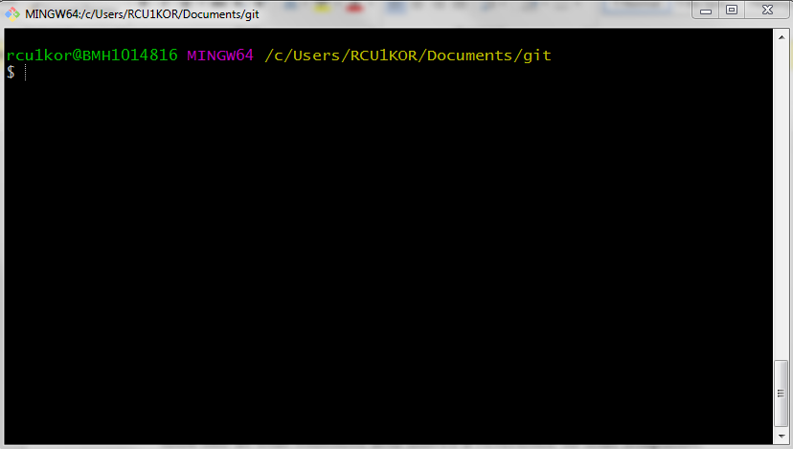
Create a new folder (i.e. project folder) and cd into newProject folder.
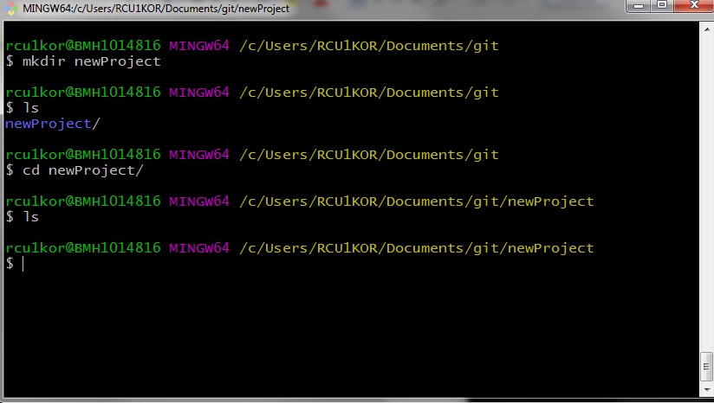
As you can see, we are inside the newly created ‘newProject’ folder and it is empty.
Now, let’s initialize it as a git repository. To do that simply type following command and hit enter.
git init
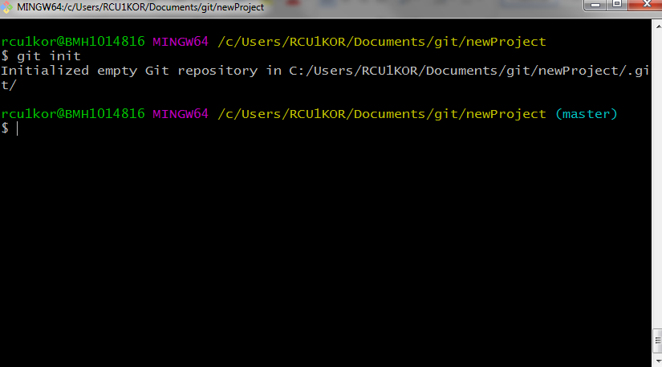
* Look at the output, it says “Initialized empty Git repository in ‘your working directory’ ”.
* Also look at the prompt, it has another field and it says ‘(master)’, it means we are in master branch. We will have a look at this later.
Now, let’s add some files to our project
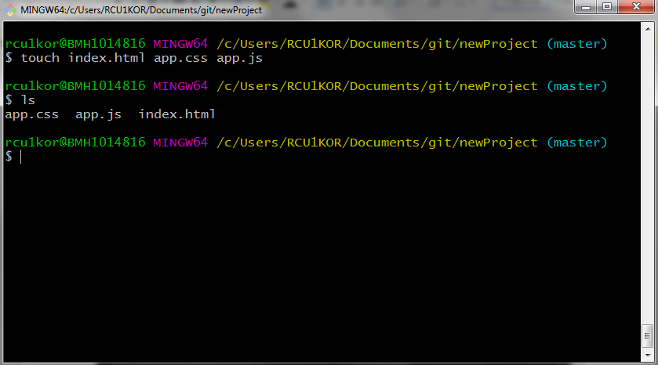
Here we have 3 files in project. Go ahead and run following command
git status
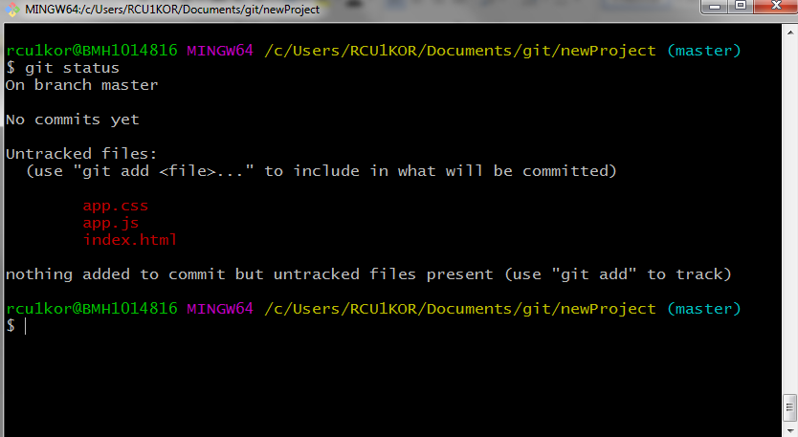
Notice, how git notifies that there are 3 untracked files. To make these files trackable by git we need to add them to staging area. Run the command –
git add .
This adds all the files in current working directory into the staging area.
No output means, command ran successfully.
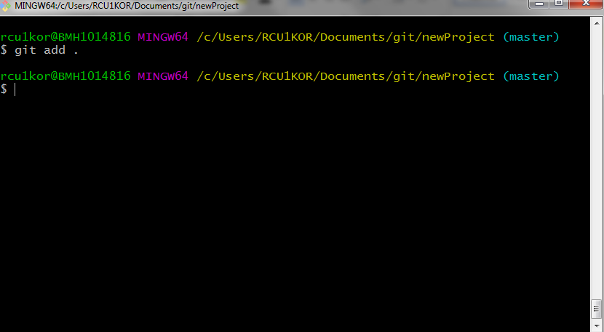
To see if it’s really been added to staging area run the git status command again.
git status
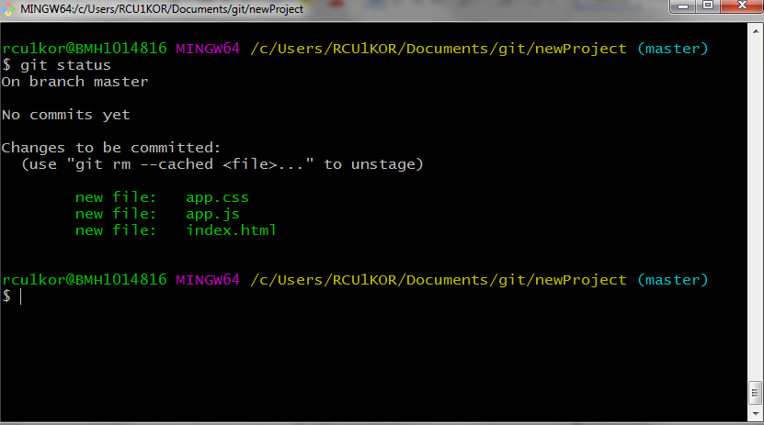
See, it’s being tracked by git now, but hasn’t been committed yet. To commit these files run following command
git commit
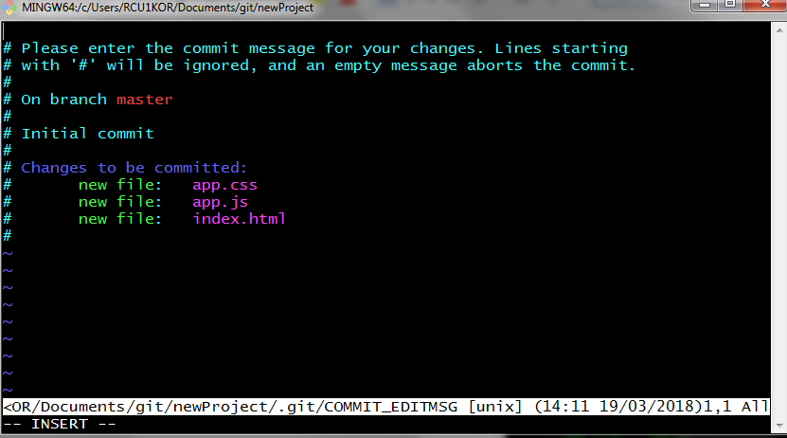
Running this command opens your default text editor and prompts for a commit message.
* A commit message is just a brief description of what you did.
* Lines starting with a ‘#’ are just comments (they are really helpful though).
Since, it’s our first commit and we haven’t really done anything, let’s pass a message saying “Initial commit”.
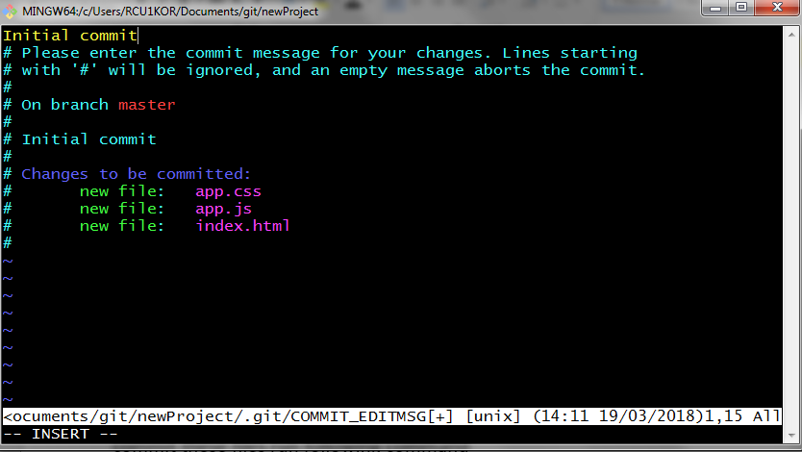
Save and exit, and you have just made your first commit.
* You can bypass the text editor by using option ‘m’ with git commit as following (use only one either the text editor or the command below).
git commit –m “Initial commit”
You will get output as below
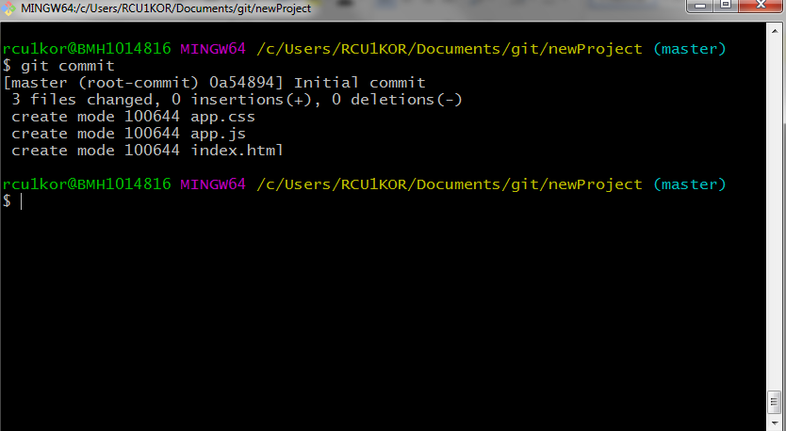

Now, to see the details of past commits we need another command. The ‘git log’ command shows details of all the past commits. Go ahead and try running it.
git log
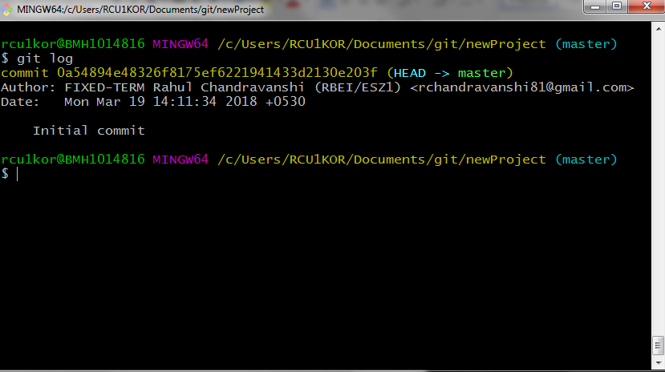
Let’s break down the output
Line no-
- It shows 40 character unique SHA value as well as HEAD pointer location (which is currently pointing to master branch)
- Name and email id of the person who did the commit.
- Date and time the commit was made.
- Commit message.
Now, let’s make changes to index.html file and make another commit.
Open index.html in your favorite text editor and add following.
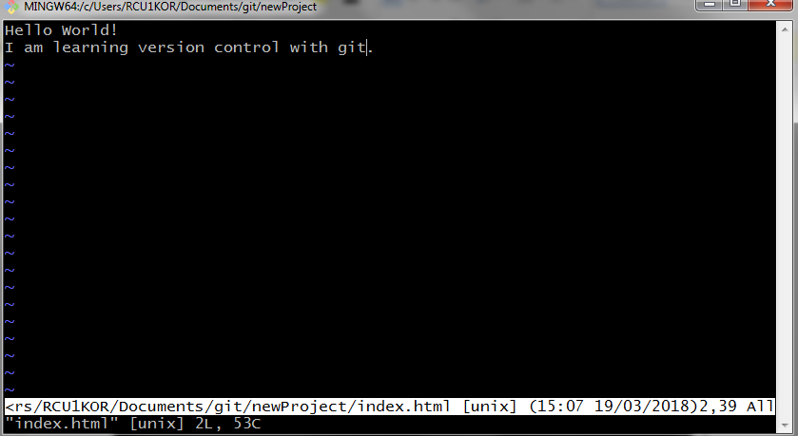
Save and exit. Now check git status
git status
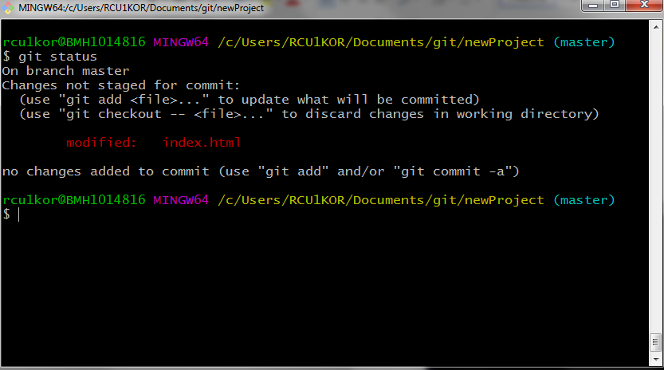
As you can see, the index.html file has been modified and git knows it. Go ahead and stage the index.html file and commit it.
git add index.html
git commit –m “Added text to index.html file”
git log
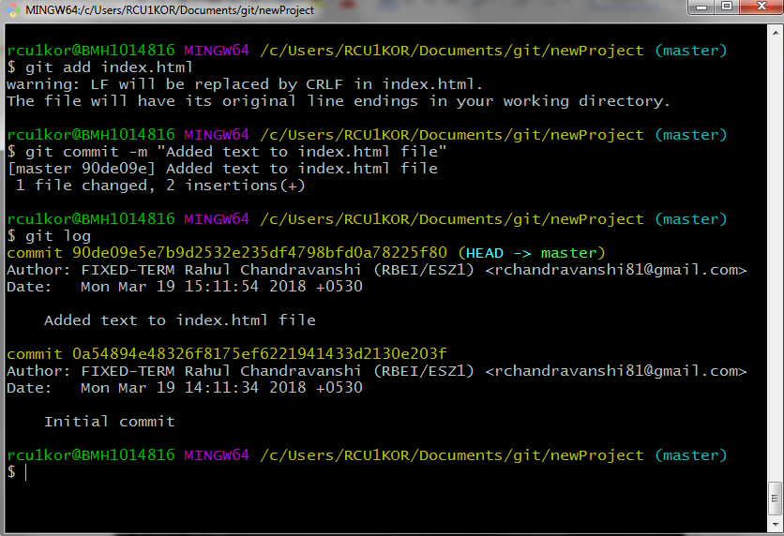
The git log shows 2 commits with respective commit messages.
Here are some variations to git log command
- git log --oneline - displays one line information with 7 characters of SHA and the commit message.
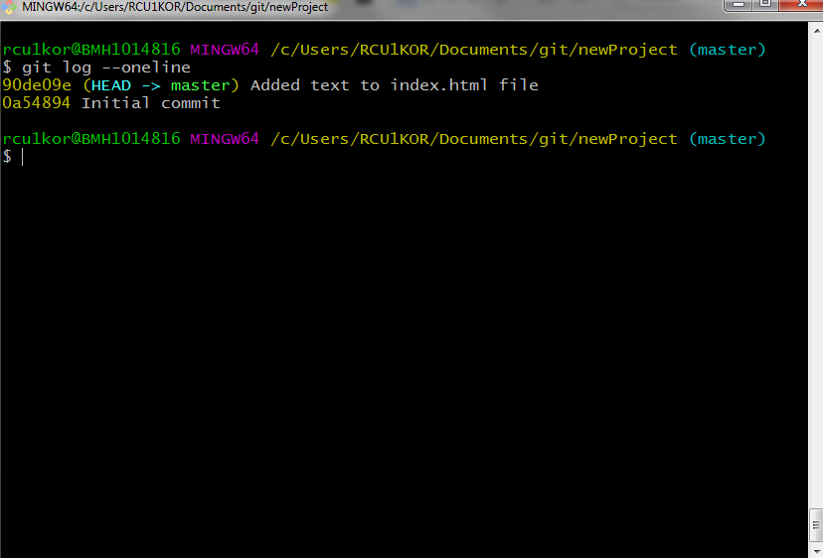
- git log --stat – Lists files that were changed as well as number of lines added and deleted.
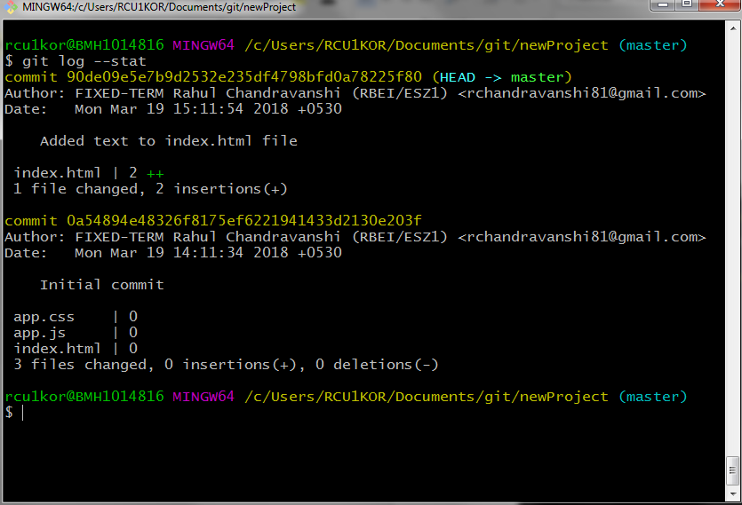
- git log -p - Allows us to actually see those changes.
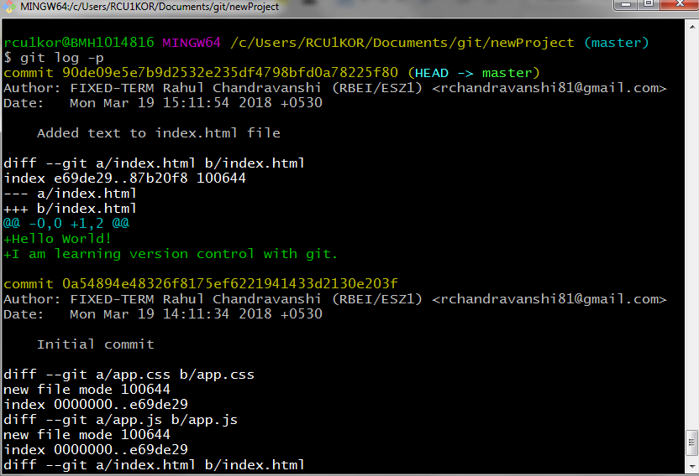

To see details of a specific commit. Use following
git show 0a54
(0a54 is first few characters of SHA of the commit I want details for, your SHA might be different.)
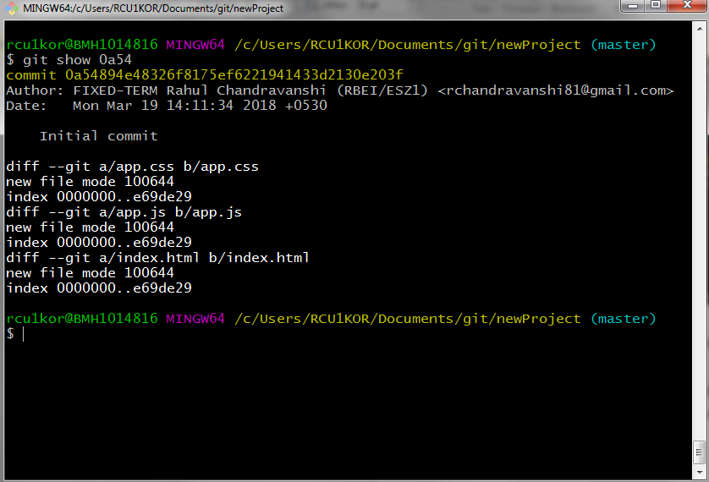

* Running “git show” without any argument will show the details of very recent commit.

Next command to master is “git diff”. What it does is, it compares the modified file with the recent commit. To see it in action, let’s modify index.html.
Open your favorite text editor and make changes as below
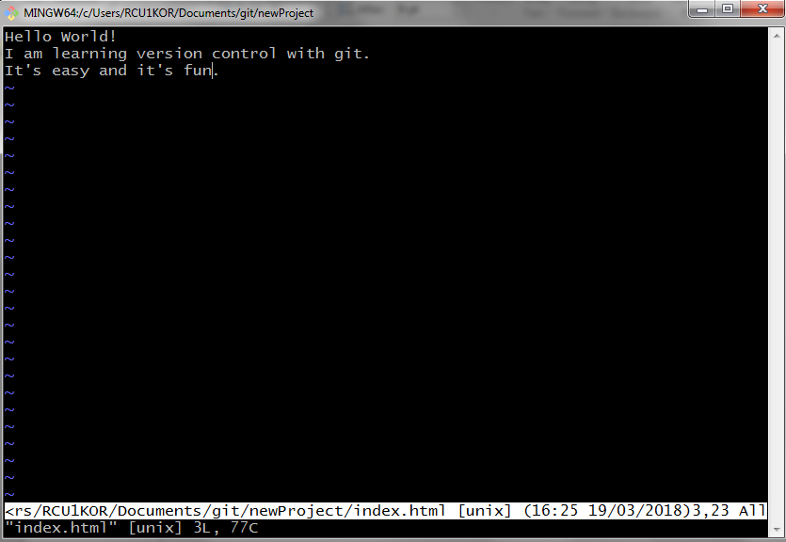
Now run the command
git diff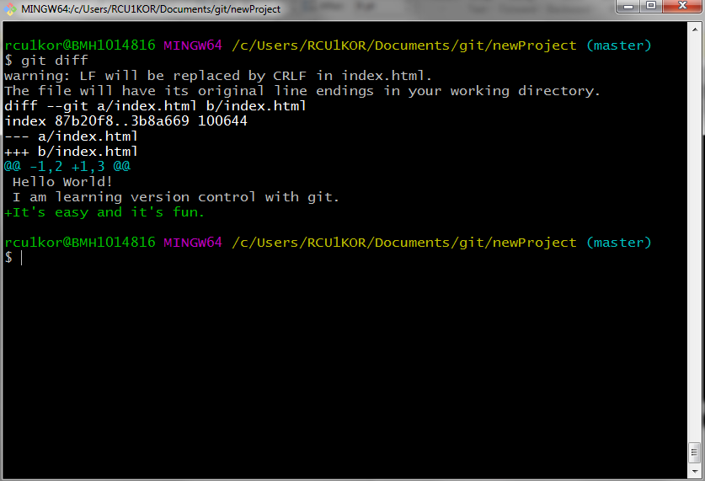

As you can notice, it tells us that a new line has been added (The lines in green and a ‘+’ in front).

So far we have learned quite a lot, from making commits to actually looking at the changes. We know how to add files to staging area, one by one or all at once by using ‘.’. What if, we don’t want certain file in our project directory to be tracked by git? We can do that too and its very easy. Just create a file called ‘.gitignore’ (The file has a ‘.’ In front of it, so it will be hidden) and add the name of the files, line by line in this file. Do that, and git will ignore those files while staging or committing. Use following commands –
Create a dummy file to ignore
touch project.docx

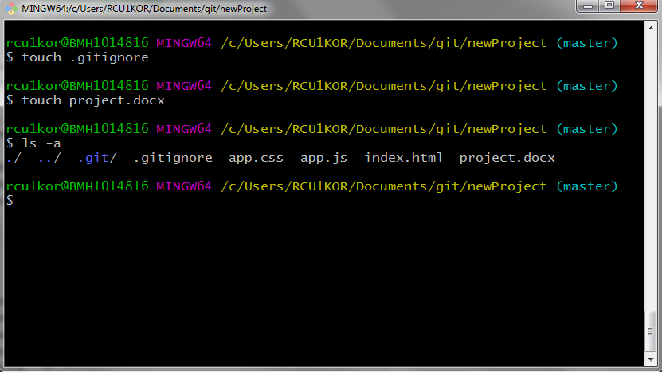
Open .gitignore in a text editor and add the name ‘project.docx’
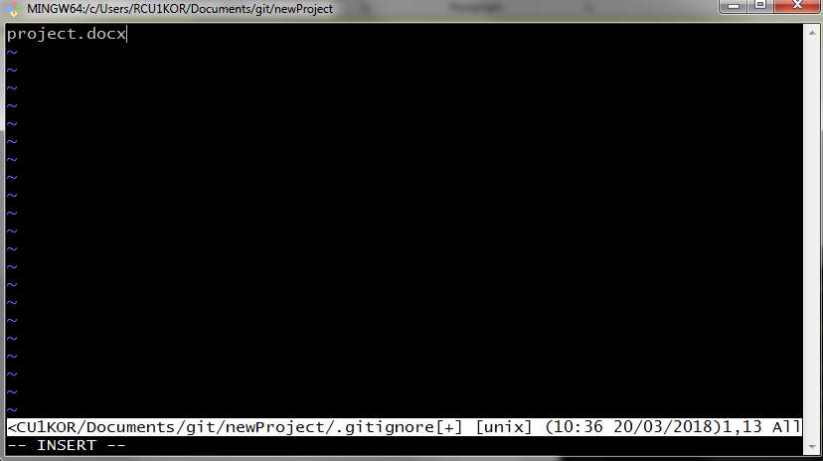

Save and exit. Now check git status to see if its working.
git status
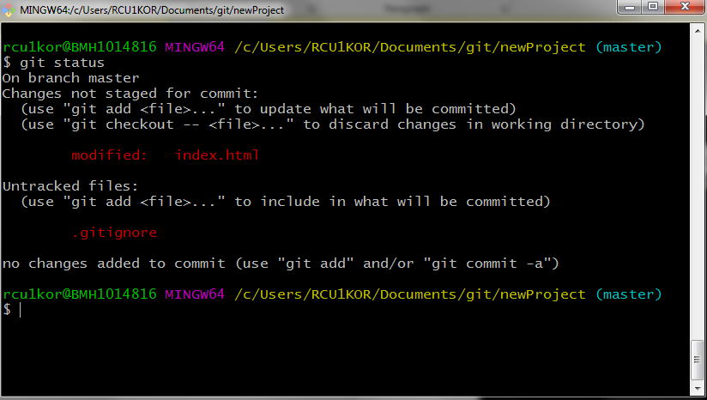

Yes, it is working. See, the only modified file git sees is the .gitignore file and not the ‘project.docx’ file. Go ahead and stage and commit this change to the repository. This is going to be our 3rd commit. Check the git log to see the commit history.
git add .gitignore
git commit –m “added the .gitignore file”
git log --oneline

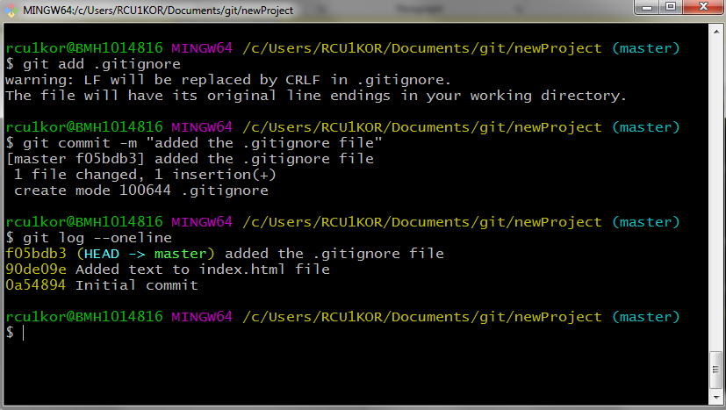

Tagging
Tags are extra piece of information, which is specific to a commit. Let’s say you have just completed a stable version of your project and you want to call it version 1.0. You can do that in commit message, but it’s not preferred. Here comes tag.
Let’s add a tag named ‘v1.0’ to our third commit. Run the command. Doing so will ask for a message. Pass a message and save and exit.
git tag –a v1.0
git log --oneline
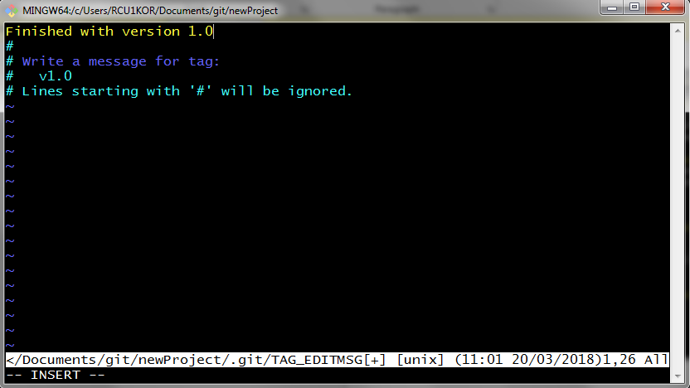
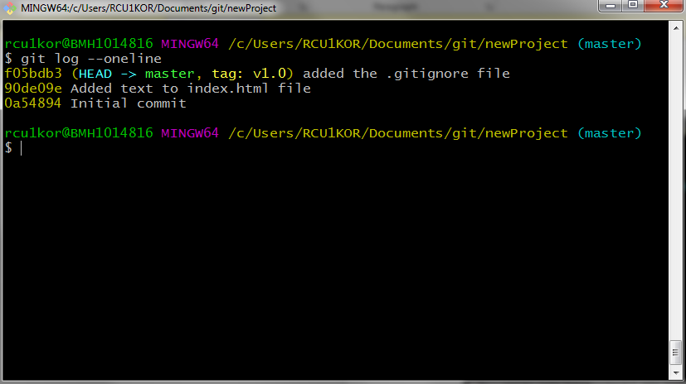

See the output, it has the tag: v1.0 for third commit.
Now, you can also add tag info to any past commit as well, all you need to do is, pass an extra argument, which is first few characters of SHA of the commit. Let’s add ‘v0.5’ tag to first commit.
git tag –a v0.5 0a54
git log --oneline
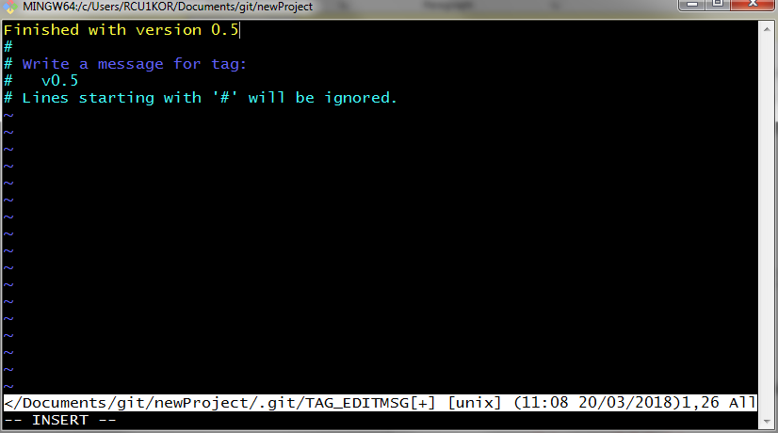
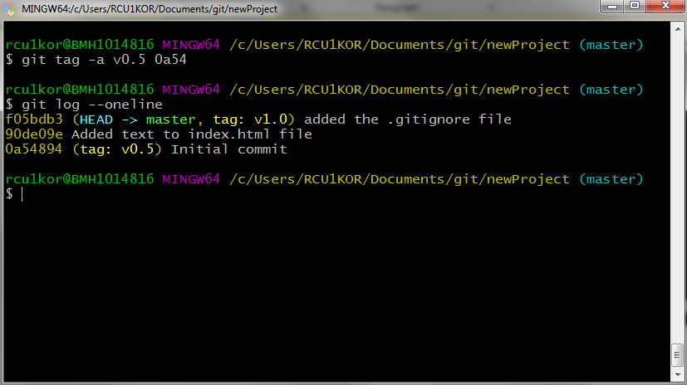

Now we have two version tags. You can also list all the tags by running ‘git tag’ command without any arguments.
git tag
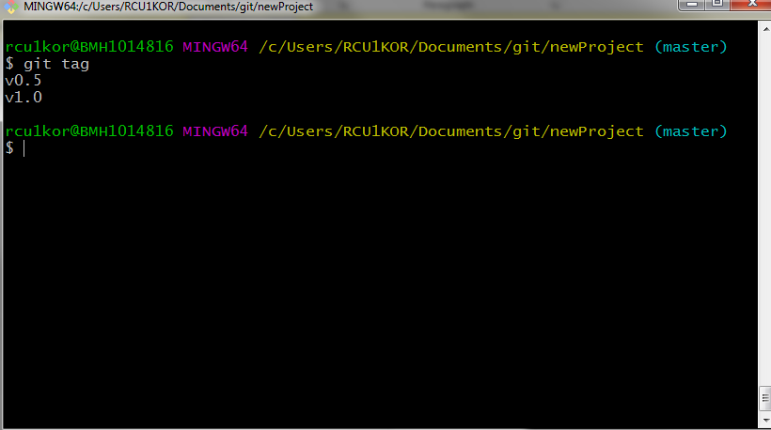

To delete a tag run following command. Here we delete the ‘v0.5’.
Remember it will delete the tag only, not the commit.
git tag –d v0.5
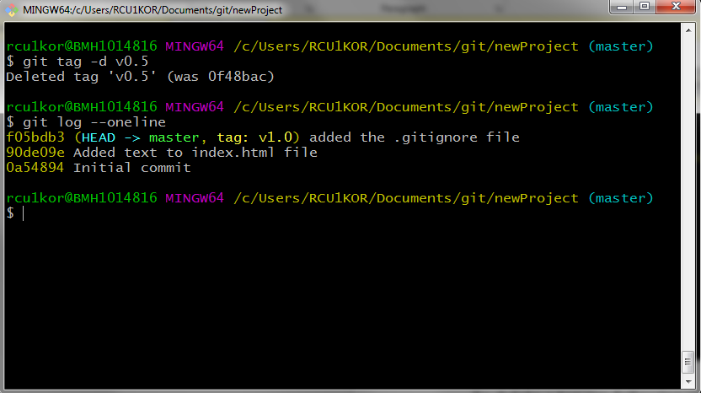

Branching
Branching lets us work in same project in different isolated environment. Changes to files in one branch doesn’t affect other. Once we are done with the development in a branch, we can merge it to master branch (we will see about merging later).

Suppose we want to add a sidebar to our current webpage. Adding this feature in master branch might break things. So, we create a new branch to work on new feature independently. To create a new branch run following
git branch sidebar
It’s time to move to our new branch. Run the command
git checkout sidebar
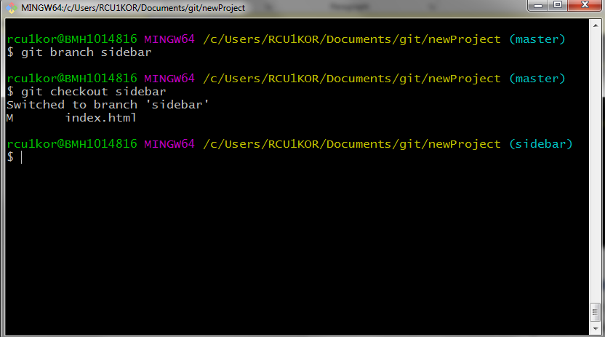
Notice the prompt. It now shows that we are in sidebar branch. Let’s make some changes to index.html file and commit it.
Open editor and make changes
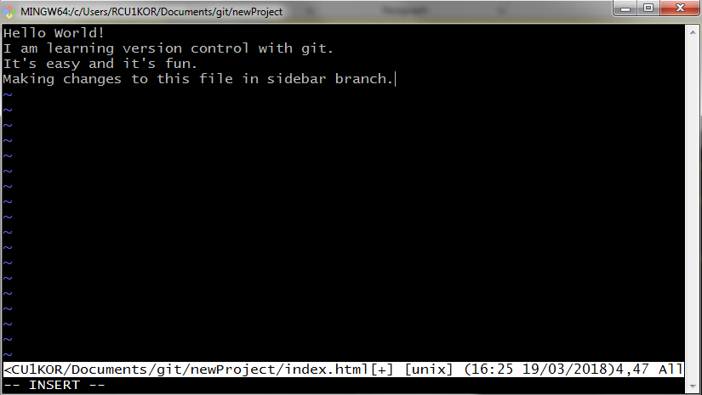
Save and exit.
Add to staging area and commit.
git add index.html
git commit –m “changed index file in sidebar branch”
git log --online
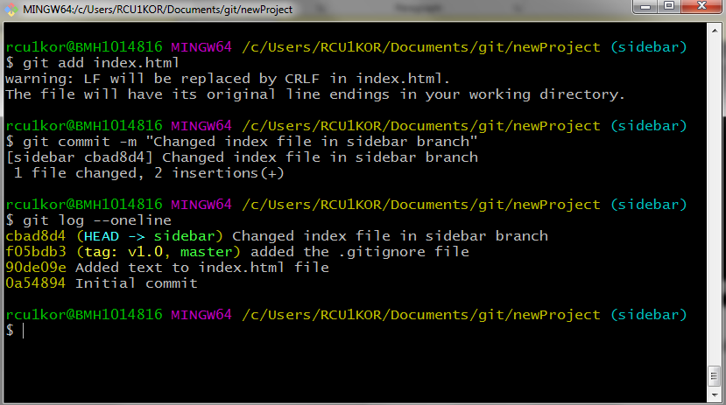

To list all the branches run
git branch
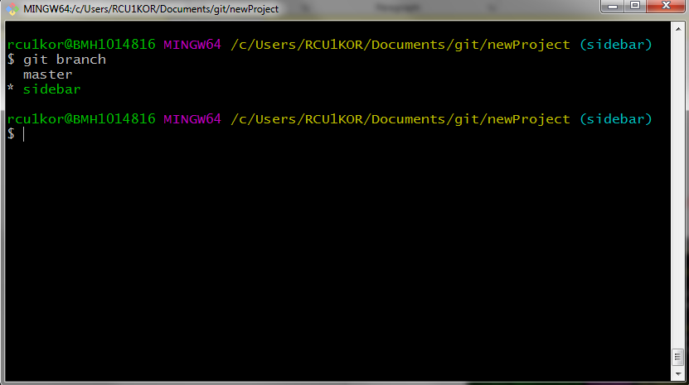
It shows a * in front of currently active branch.

* To delete a branch use command (Make sure you don’t need this branch anymore or you have already merged it to another branch)
git branch –d branch_name

Merging
Merging helps combine two branches. Git automatically figures out the difference between two files in two different branch and merges them line by line.
To merge a branch to master branch, switch to master branch
git checkout master
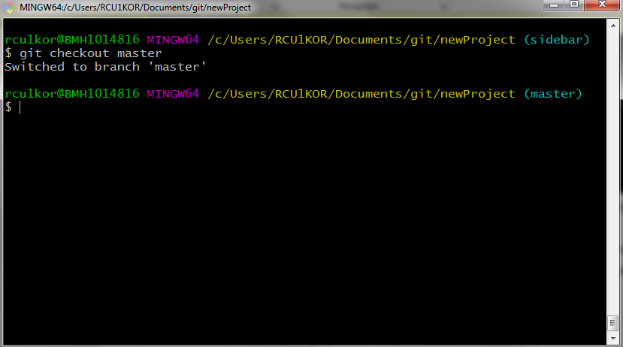
As you can see the prompt changed to master from sidebar.
Now run following to merge sidebar to master-
git merge sidebar
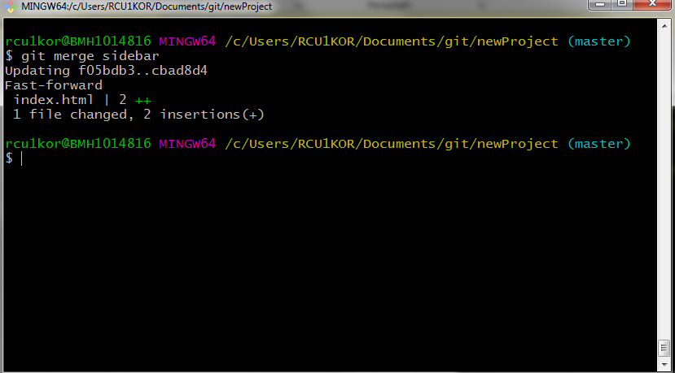
Now the master branch will have changes made in sidebar branch as well.
Here, since git tracks a file line by line, so modification in a file at same line in two different branches might cause a conflict known as merge conflict. The programmer has to resolve this manually, but don’t worry it’s easy. All we have to do is choose which lines we want from which branch. Git also adds some markers to make it easy to find which lines caused the conflict.
To demonstrate let’s create a conflict and then we will resolve them.
On master branch, change the first line of index.html to this
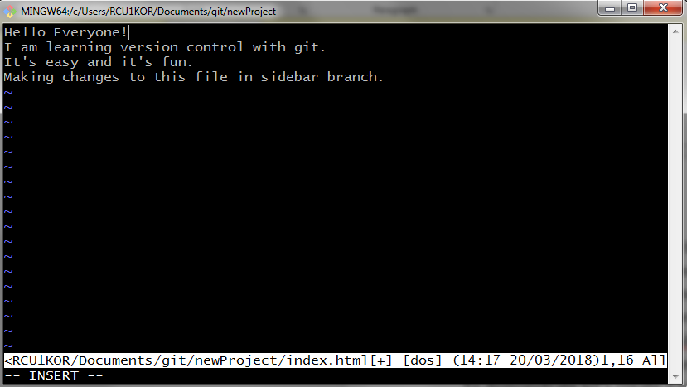
Stage and commit the change.
git add index.html
git commit –m “change first line of index file on master branch”

Now, move to sidebar branch using git checkout command
git checkout sidebar

On sidebar branch change the first line of index.html to this
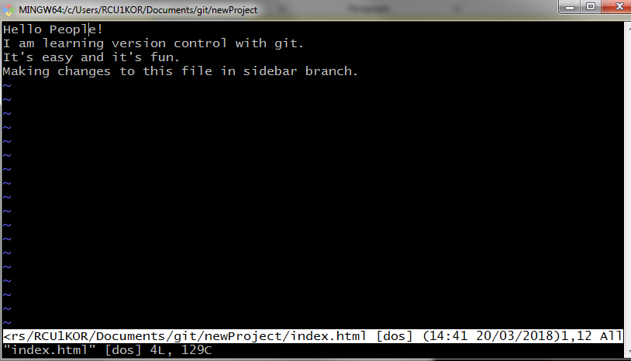
Stage and commit the changes
git add index.html
git commit –m “change first line of index file on sidebar branch”

It’s time to merge and see what happens.
Make sure to checkout to master branch and run this
git merge sidebar
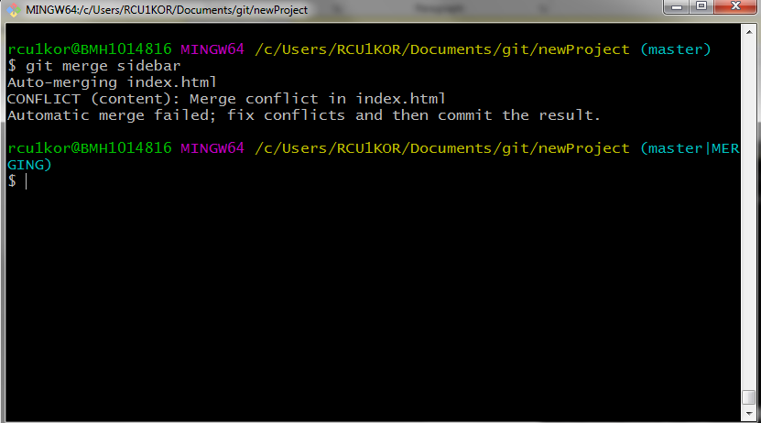
Look at that scary merge conflict. It says, ‘Automatic merging failed’. It also tells us that conflict occurred in index.html file. Also have a look at the prompt. It means we are in a merging process and we manually need to resolve the conflict.
To do that open the index.html file, which may look like this with some markers
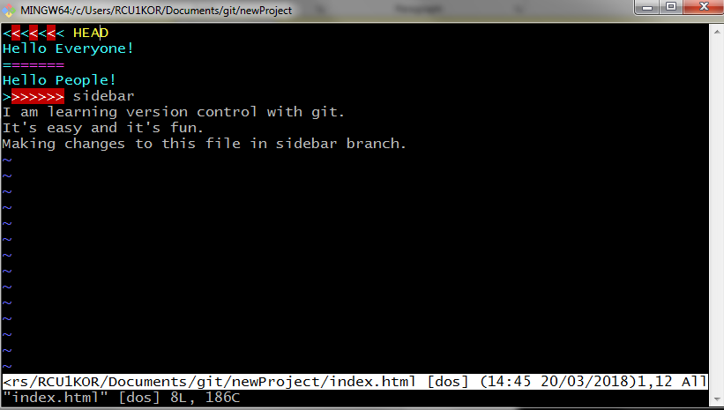
Text from
<<<<<<<
to
=======
Is in current branch and
text from
=======
to
>>>>>>>
Is in sidebar branch.

Here just choose what you want to keep and remove everything else (the markers too). It may now look like this,
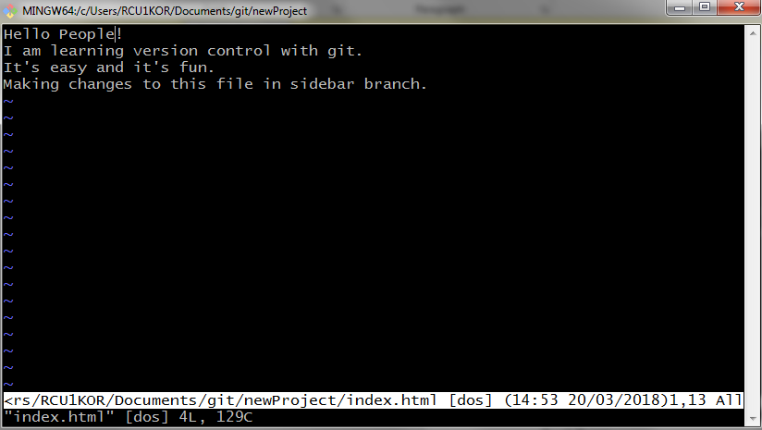
Save and exit, stage and commit and we are good.
The conflict will be gone.
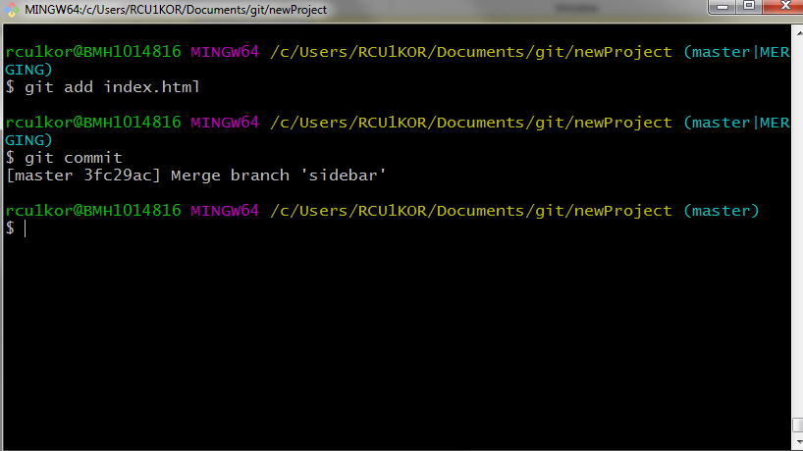
Use the following command to see the commit history with branches in much comprehensive way
git log --oneline --graph --all
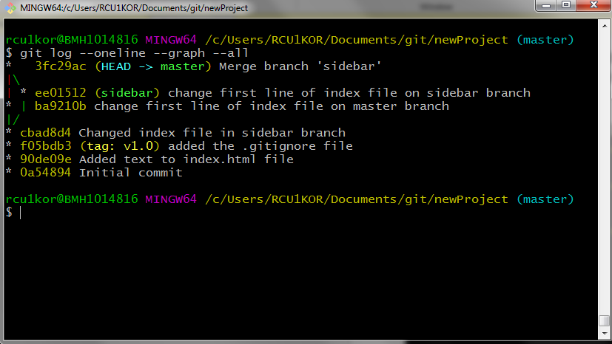

Undoing changes
One might make a mistake, be it a typo in commit message or forgetting to add a file into a commit. We can revert a commit and we will also look at how to delete a commit.
The first command is ‘git commit --amend'. It allows us make changes to a recent commit. This could be a simple typo in commit message or you just forgot to add a file. To see it in action lets edit our index file and stage it and commit it with a message that has an error.
Edit the index file as following.
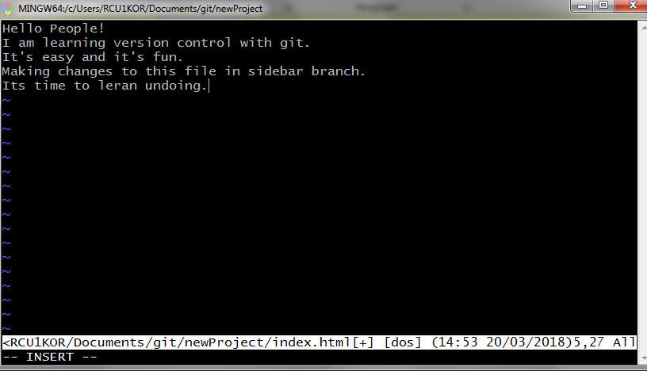

Save, exit, stage and commit
git add index.html
git commit –m “added another line to index file”

Now, what if I want to add a ‘.’ (full stop) at the end of commit message. To do just that run the command
git commit --amend
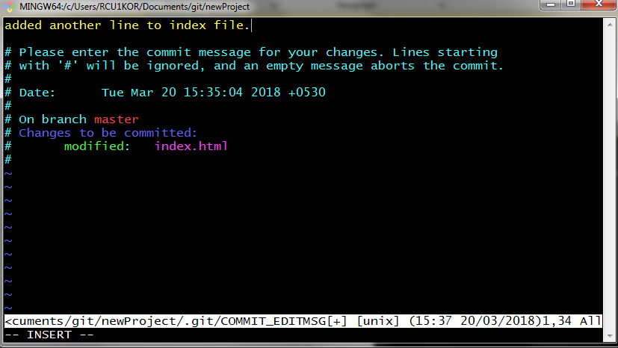
Make the changes, save and exit. There you go, commit message has been updated. You can check the new message (with a full stop) by running
git log --oneline 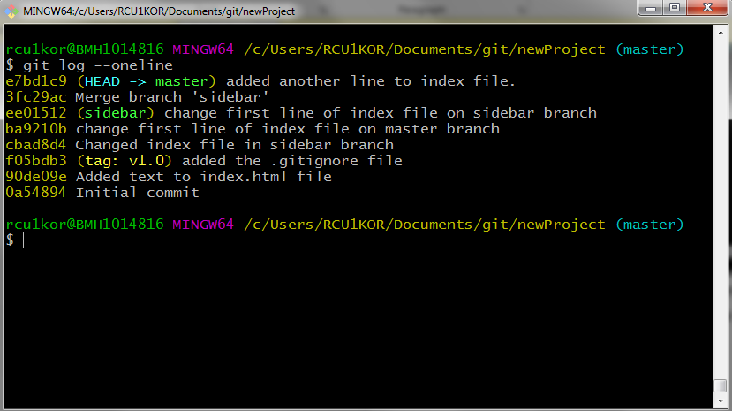

Forgot to add a file in last commit? Don’t worry!
To add a file, follow these steps
- Edit / create the file
- Add the file to staging area using git add command
- Now commit the file using git commit --amend

Next up, what if we want to revert an entire commit. We can do that too. Let’s see it in action.
Make some changes to index file, totally erase it and add something
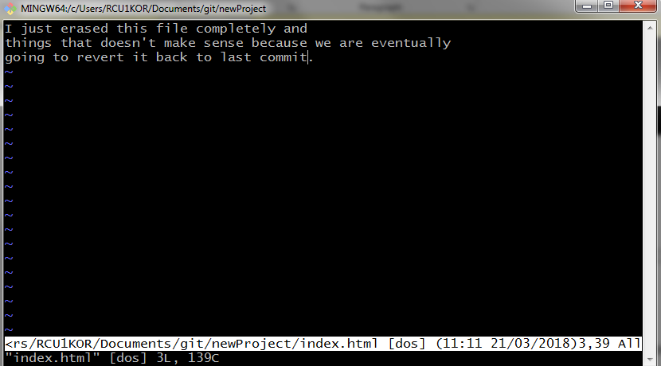

Save and exit, stage and commit.
git add index.html
git commit –m “senseless commit”
git log --oneline

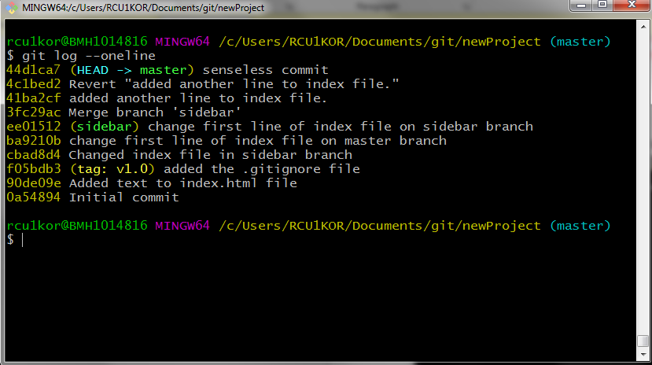

It’s time to reverse the commit.
Run the command with commit’s SHA
git revert 44d1ca7

This will perform a new commit with changes reversed. Just accept the default commit message (You can change the message if you want).
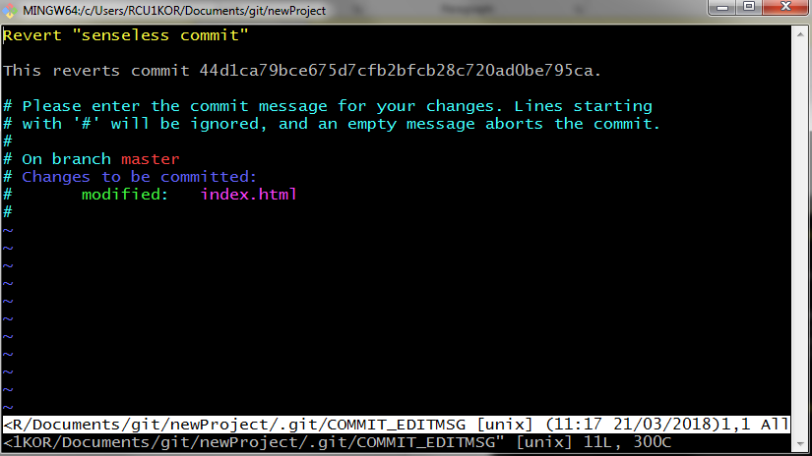
Save and exit.
Now you can open index.html file to see if the commit has been reversed?
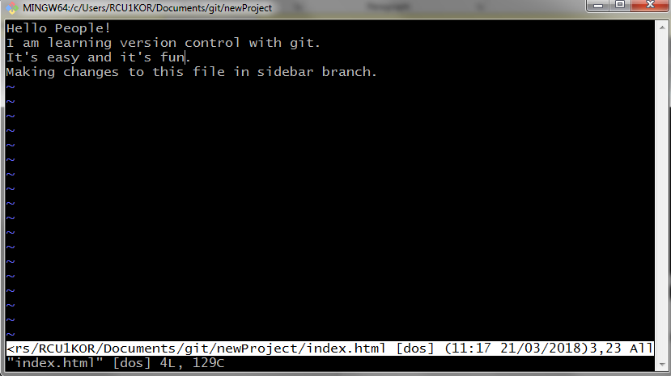
Yes, it has been.

Now, one last thing.
Can we delete commits?
Yes, we can but it could be pretty dangerous. So, make sure you don’t need that commit.
To start we resetting (deleting) commits, we need to know about
Relative Commit Reference
There are 2 symbols that represent a commit relative to HEAD.
- ^ – indicates the parent commit
- ~ – indicates the first parent commit
Here's how we can refer to previous commits:
- the parent commit – the following indicate the parent commit of the current commit
  - HEAD^
  - HEAD~
  - HEAD~1
- the grandparent commit – the following indicate the grandparent commit of the current commit
  - HEAD^^
  - HEAD~2
- the great-grandparent commit – the following indicate the great-grandparent commit of the current commit
  - HEAD^^^
  - HEAD~3
The git log looks like this
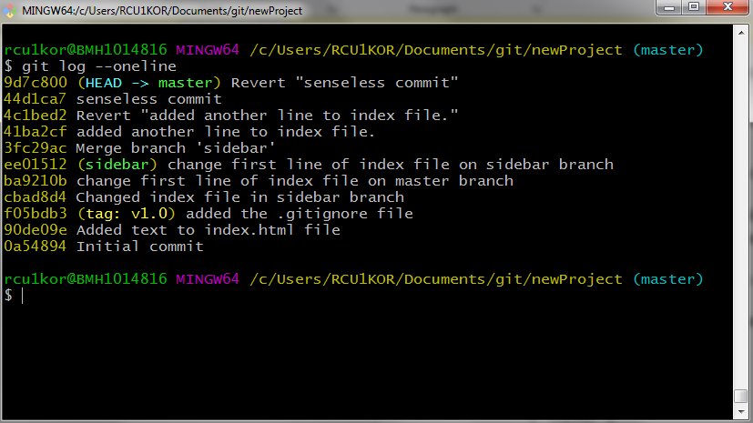
Run the command
git reset HEAD^^
and top two commits will be deleted (I lost my progress, so, can not show it here).

So, this is it. We have gone through a lot of git commands. I have tried to attach input commands and output screenshots as well.

